
Lesson 8: Under Pressure
GDevelop
VIDEO GAME CREATION
This week: give the enemies you dodge last week actual stakes. An enemy reaching the bottom now costs a life - lose all 3, and "Game Over" appears.
Open your own [YourName]Game project from Lesson 7 - don't start a new one.
Tip: the core exercise needs no new assets - this reuses last week's escape-cleanup code and just gives it a real consequence. For Level 3 sound, use the provided sfx_lifelost.wav and sfx_gameover.wav from the Lesson 8 Assets folder.

Setup
- Open your [YourName]Game project from Lesson 7.
- Add a new Text object, name it LoseText, set its content to "Game Over", place it on screen, and hide it (uncheck its visibility).
- Add a new scene variable Lives, default value 3.

Level 1 - Minimal (MVP)
Every enemy that reaches the bottom unshot now costs the player one life, tracked starting at 3. The moment lives reach zero, "Game Over" appears on screen.
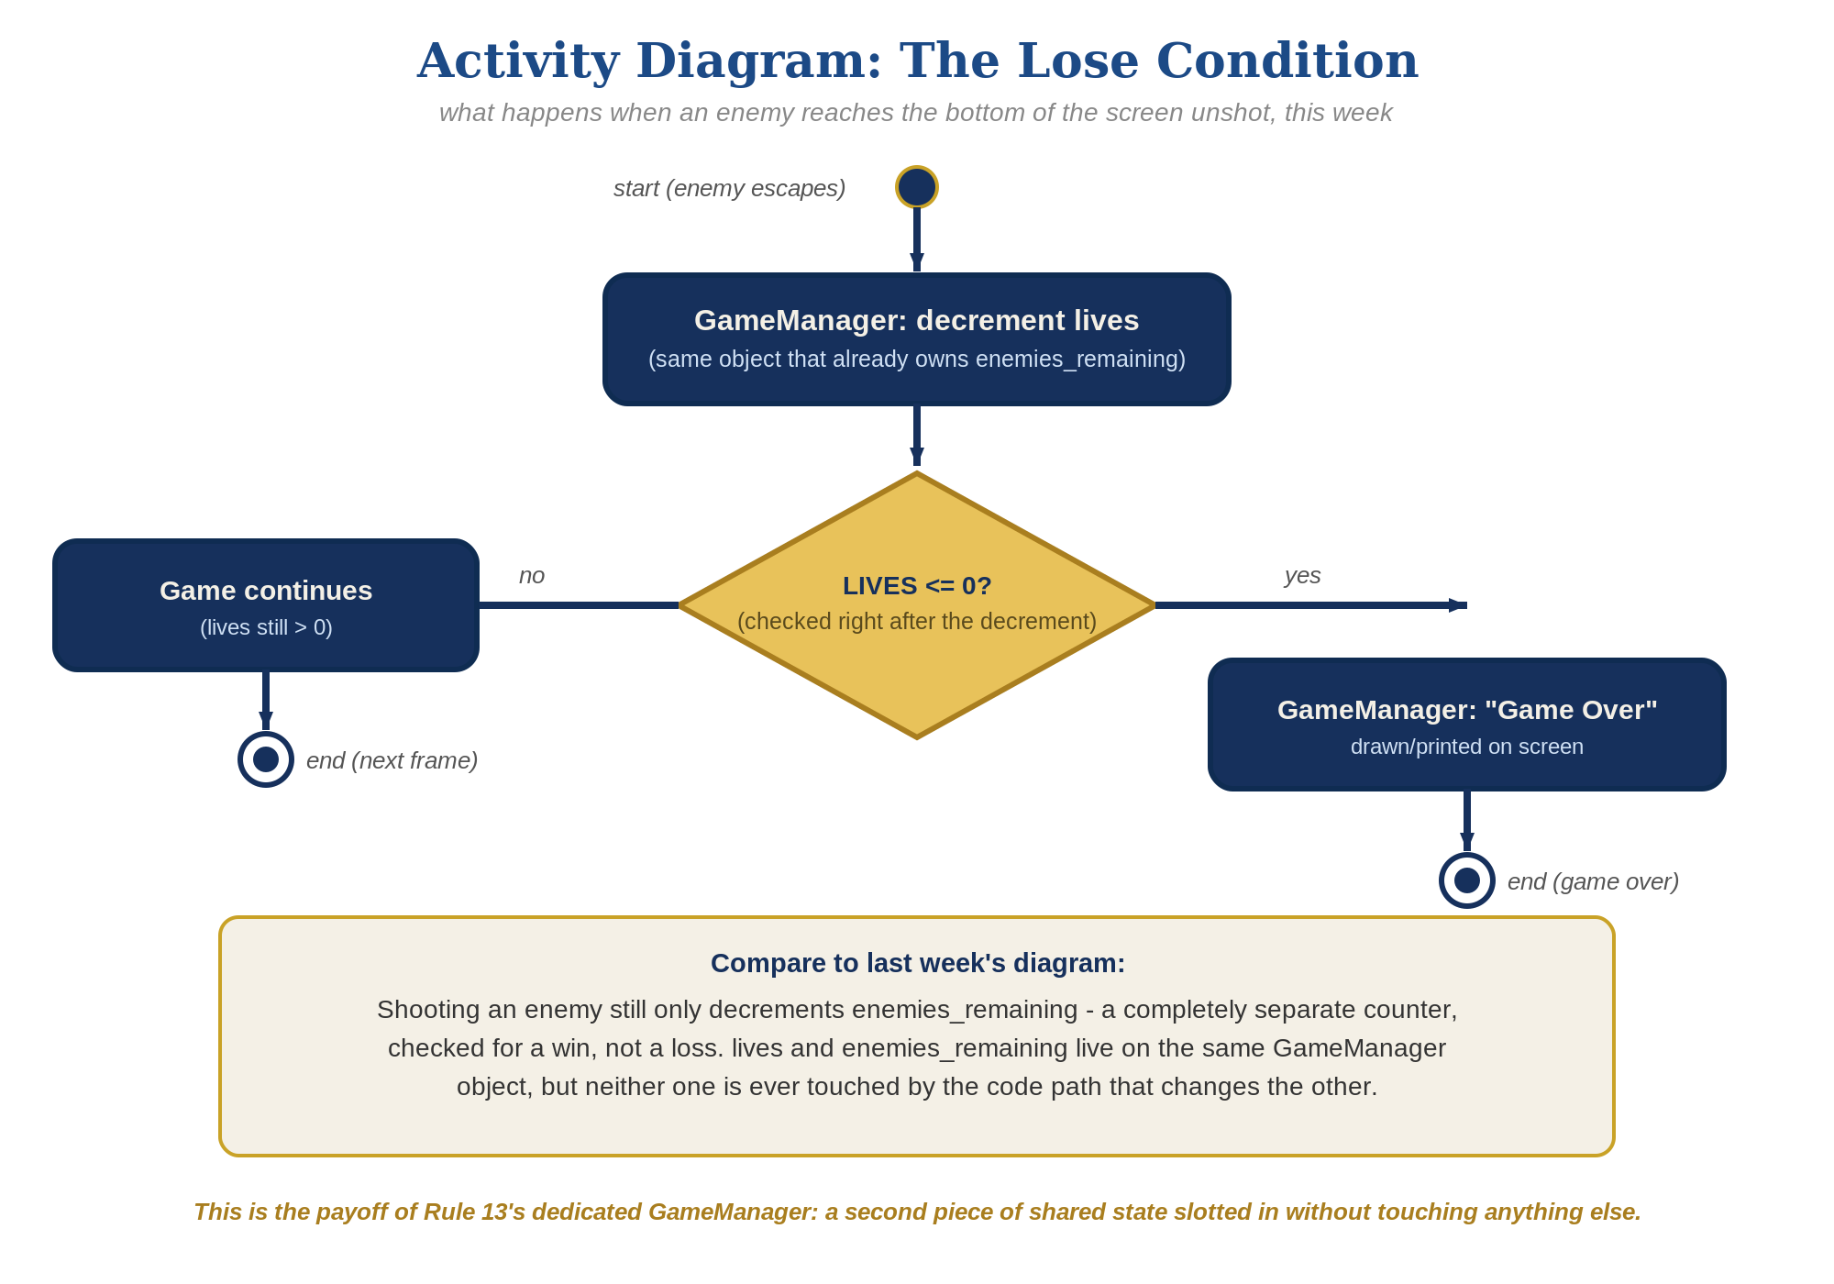
The lose-condition logic behind this week's exercise - the same shape in every engine, whatever the exact code or blocks look like.
- Find the escape-cleanup event you built last week (Condition: Enemy.Y() > 750 -> Action: Delete Enemy). Add a new action to it: Lives = Lives - 1 (code below).
- Add a new event: Condition "Lives <= 0" -> Action "Show" LoseText.
- Click the green Preview button and let all 3 lives run out by letting enemies escape unshot - "Game Over" should appear the instant the third one escapes.
Highlighted lines are new this week; everything else is code you already have.
(existing escape event, revised)
Condition: Enemy.Y() > 750
Action: Lives = Lives - 1
Action: Delete Enemy
(new event)
Condition: Lives <= 0
Action: Show LoseText

Level 2 - Complete (Alpha/Beta)
Shooting an enemy never costs a life, and letting one escape never counts as a kill - the two counters stay completely independent.
- Shoot an enemy and confirm Lives does NOT change - only the Combat group's collision event, and EnemiesRemaining, should be involved.
- Let an enemy escape and confirm EnemiesRemaining does NOT change - only the escape-cleanup event, and Lives, should be involved.
- Confirm LoseText appears exactly once, exactly when Lives reaches zero.

Level 3 - Refined (Ready to Publish) - pick any that interest you
- Visual: add a second Text object showing the current Lives value, updated by the escape-cleanup event - a nice touch, though the full scoreboard-style UI is coming properly in Lesson 9.
- Sound: import the provided sfx_lifelost.wav and sfx_gameover.wav, then add a "Play a sound" action to the escape-cleanup event (sfx_lifelost.wav) and another to the Lives <= 0 check (sfx_gameover.wav).
- Structure: the escape-cleanup event now changes Lives, and the Combat group changes EnemiesRemaining - two clearly separate events, neither one referencing the other's variable. Keep it that way as the event sheet grows.

If Something's Wrong
- Lives decreases when you shoot an enemy: confirm the Lives = Lives - 1 action is only in the escape-cleanup event, not accidentally added to the Combat group too.
- "Game Over" never appears: confirm Lives actually starts at 3 (check the scene variable's default value) and that the Enemy.Y() > 750 condition is actually true for escaping enemies.
- LoseText and WinText overlap on screen: reposition one of the two Text objects in the scene editor so they don't draw on top of each other.

Want More?
Student Resource List > GDevelop section, or gdevelop.io/tutorials

